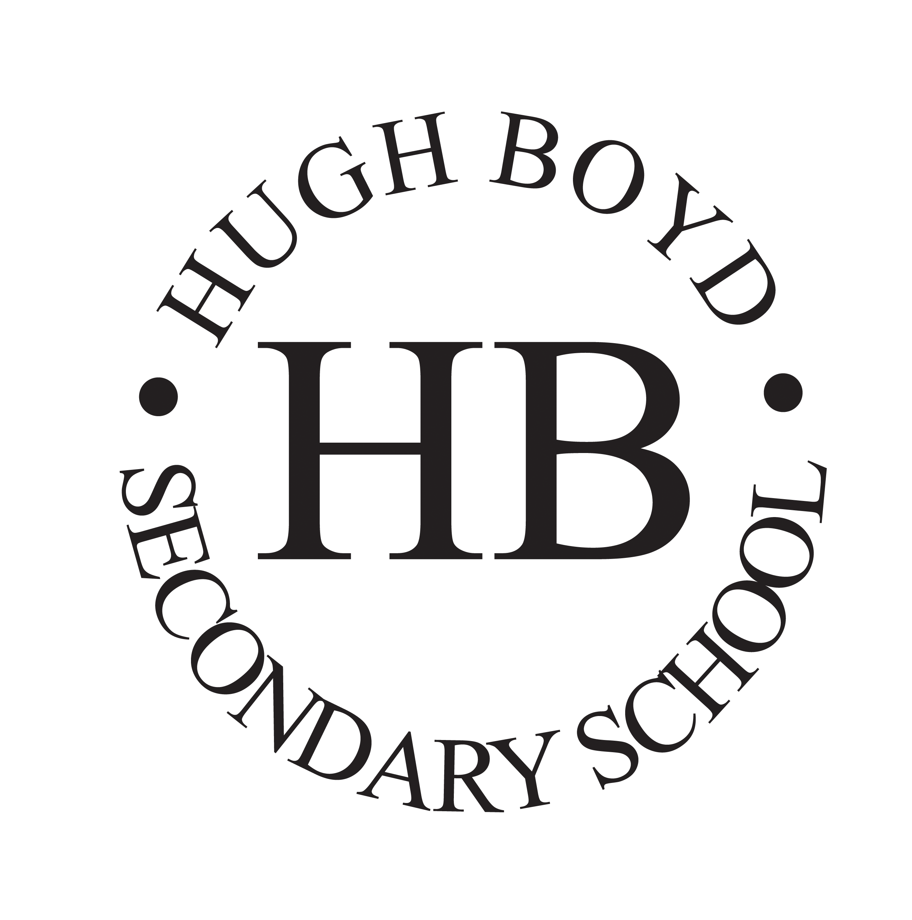 | HUGH BOYD INCENTIVE  INTERNATIONAL BACCALAUREATE  MIDDLE YEARS PROGRAM  2024-2025 | 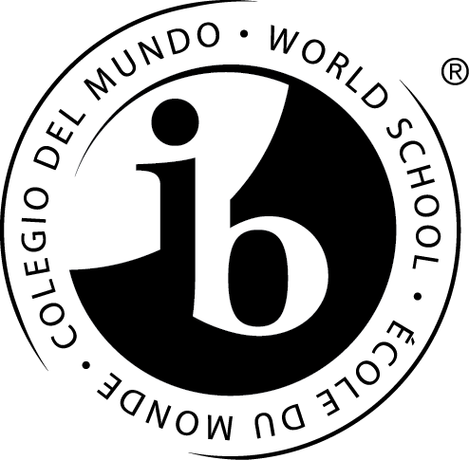

The Incentive and IB philosophy is to promote the development of holistic learners who demonstrate academic drive, leadership, teamwork, diligence, empathy and open mindedness as socially responsible local and global citizens. Incentive students will have opportunities to coordinate and facilitate local and global service initiatives, participate in public performances, compete at science competitions and participate in outdoor adventure trips.

The Incentive program includes Grades 8-10. Course programming is a hybrid model, with students enrolling in enriched Incentive classes of Science, English and Social Studies with opportunities to take electives in the mainstream.

Students in the Incentive Program will receive IB MYP and Incentive Program certification in an enriched, engaging and challenging environment. Through their experiences in Incentive, our students will have developed a solid foundation of personal attributes, identity and confidence as they enter their senior grades of school.

CRITERIA FOR SELECTION
- if using traditional report cards, a “B” or better average in academic achievement OR if using proficiency standards, a level of “proficient” or “extending”
- demonstrates solid work habits, initiative, drive and diligence
- demonstrates empathy, community citizenship and desire to participate in service opportunities
- works effectively individually and as a member of a team
- demonstrates creative thinking and problem solving
- possesses leadership and effective communication skills

Students interested in the Incentive program should complete and submit the attached application form by Friday, February 2, 2024 by dropping it off at the office or by emailing it to boyd@sd38.bc.ca

Please ensure completion of a school transfer application form if you are applying out of catchment and submit this to the Hugh Boyd office (https://sd38.bc.ca/student-registration/transfer-applications). For more information, please contact Mr. Aura at Hugh Boyd Secondary.

Brock Aura
604 668 6615
baura@sd38.bc.ca

HUGH BOYD INCENTIVE
APPLICATION PROCESS
2024-2025

APPLICATION PROCESS

- Please submit the following to Hugh Boyd by February 2, 2024:
  - Incentive program application form
  - Essay response (see bottom of application form)
  - If using report cards, a photocopy/scan of your June report card from your last grade and your first report card from your current grade

OR

If using the e-portfolio, please either print or screen shot the proficiency levels

- Teacher referral forms and any other reference letters should be submitted directly to Hugh Boyd by February 9th, 2024

- ***if you are not within the Boyd catchment, complete the school Transfer Application. Students cannot be interviewed until the Transfer Application is approved by the district.

- You will be contacted to arrange an interview at Hugh Boyd. At this interview, you will be given an opportunity to discuss or show:

  - samples of work from Social Studies, English and Science
  - extra-curricular involvement, such as sports, scouts, music etc.
  - service activities, such as community volunteering, school leadership events etc.
  - accomplishments, such as awards, certificates, medals etc.

- At the interview you may also be asked to complete a comprehension/writing sample and complete a team activity/presentation

HUGH BOYD INCENTIVE
INTERNATIONAL BACCALAUREATE MIDDLE YEARS PROGRAM

INCENTIVE APPLICATION
2024-2025

Name: __________________________________________________ _________
First Name Last Name Gender

Birth date: _____________________________________
Month Day Year

Address: ______________________________________ _________ Number and Street Postal Code
Home Phone Number: ____________________________

Parents/Guardian Names: ________________________ ____________________________

Parent/Guardian #1 Cell: __________________ Parent/Guardian #2 Cell: __________________

Parent Email Address: _______________________________

Present School: ___________________________ Grade: _____________

Teacher’s Name: ___________________________

Student Signature: ________________________________

Parent Signature: _________________________________

Please submit a typed essay that answers the following questions:

- Why do you want to be in the Incentive Program?
- What personal attributes, experiences, achievements make you a qualified candidate for the program?

HUGH BOYD INCENTIVE
INTERNATIONAL BACCALAUREATE
MIDDLE YEARS PROGRAM
2024-2025

CONFIDENTIAL TEACHER REFERRAL FORM

Send directly to Hugh Boyd Secondary (hardcopy or email) no later than February 9th, 2024
(forms can be emailed to boyd@sd38.bc.ca)

STUDENT: __________________________

TEACHER:__________________________ SCHOOL:__________________________

Instructions: Please fill out the form as honestly as possible to assist us in our selection process; this information helps us to determine the students for whom this will be a positive and enriching experience.

Please use a scale of 1-5 to evaluate the student’s aptitudes focused on the new Curricular Core Competencies, with 1 not meeting expectations and 5 exceeding expectations. Please provide specific comments in addition to the numerical assessment, highlighting student strengths and areas for improvement.

CORE COMPETENCY | RANK
Communication: Demonstrates the ability to express knowledge, experiences and information using a variety of platforms. Demonstrates fluency in numeracy and literacy.
Thinking: Demonstrates the ability to think critically and creatively in processing new information and solving problems.
Personal/Social: Demonstrates the development of a socially aware and responsible citizen in the school and community.
In your professional opinion, please check off your recommendation of the applicant.

I highly recommend this student for the Incentive Program

I recommend this student for the Incentive Program

I have reservations to recommend this students for the Incentive Program

I do not recommend this student for the Incentive Program

Please provide a rationale for your opinion of the student’s suitability for the Incentive Program:

Teacher Name: ___________________________________________

Signature: _______________________________________________

Thank you very much for your time and effort in completing this reference form.

